***Name:*** *Jay A. Sorathiya*

*Link to Git-hub repository:* [*https://github.com/JaySRT/PythonFlaskDockerPycharm/tree/Flask_oscar_dataset_Docker_mysql*](https://github.com/JaySRT/PythonFlaskDockerPycharm/tree/Flask_oscar_dataset_Docker_mysql)

* 1. *a.* ***YOUR*** *project showing postman listing all records:*

1. 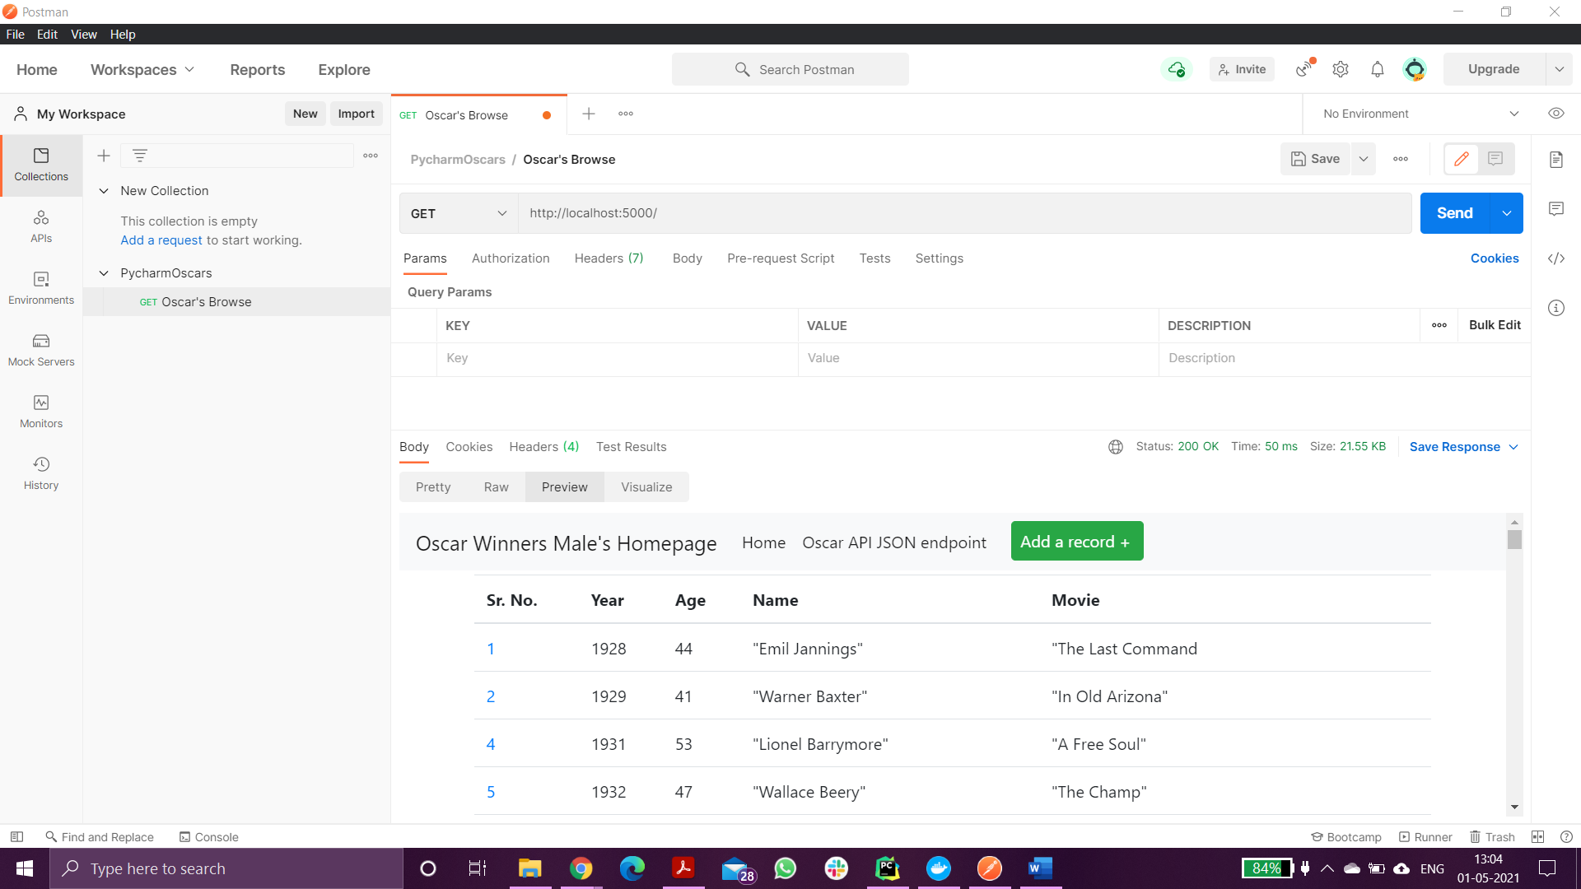
   1. *b.* ***YOUR*** *project showing postman showing one record with a get request:*
   2. 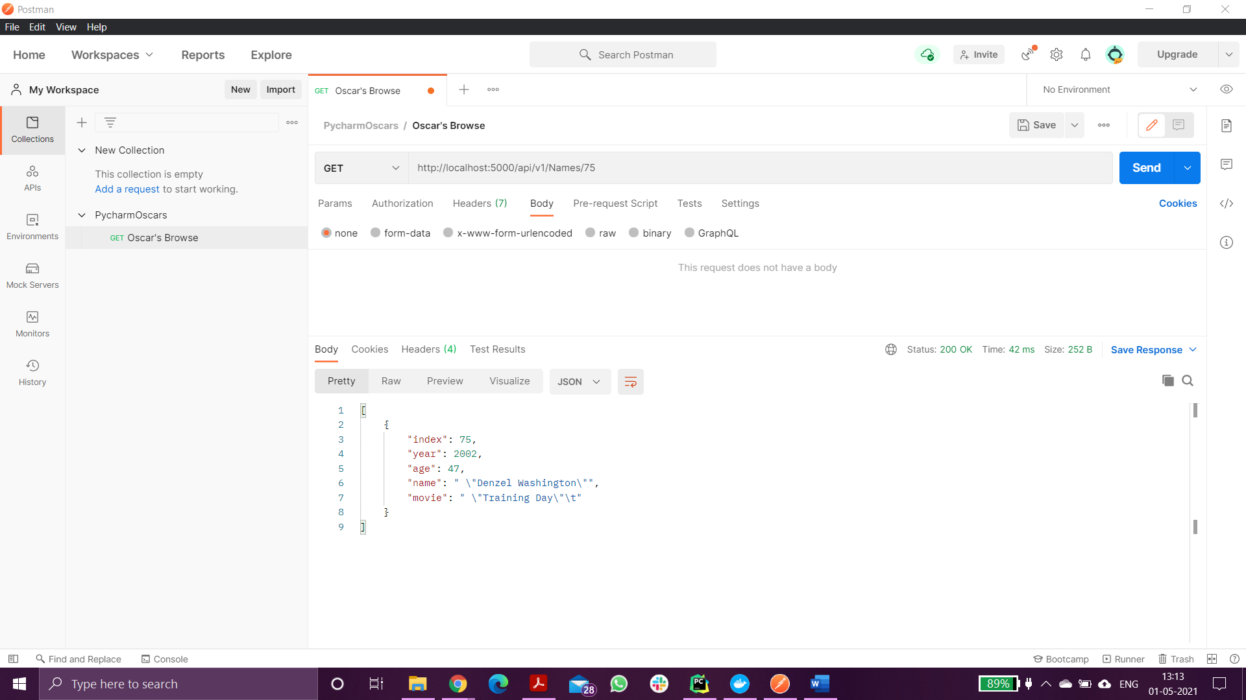
   3. *c.* ***YOUR*** *project showing postman creating a record by showing the post request and the results in the record listing*
   4. 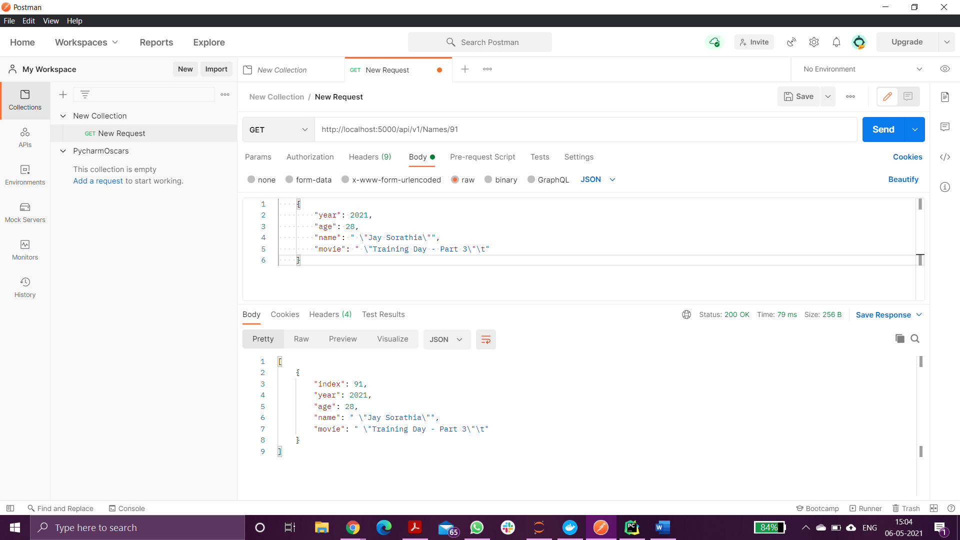
   5. *d.* ***YOUR*** *project showing postman edit a record by showing the put request and the results in the record listing*

Edit record – Added “Part 2” to the movie name as an update via Put request.

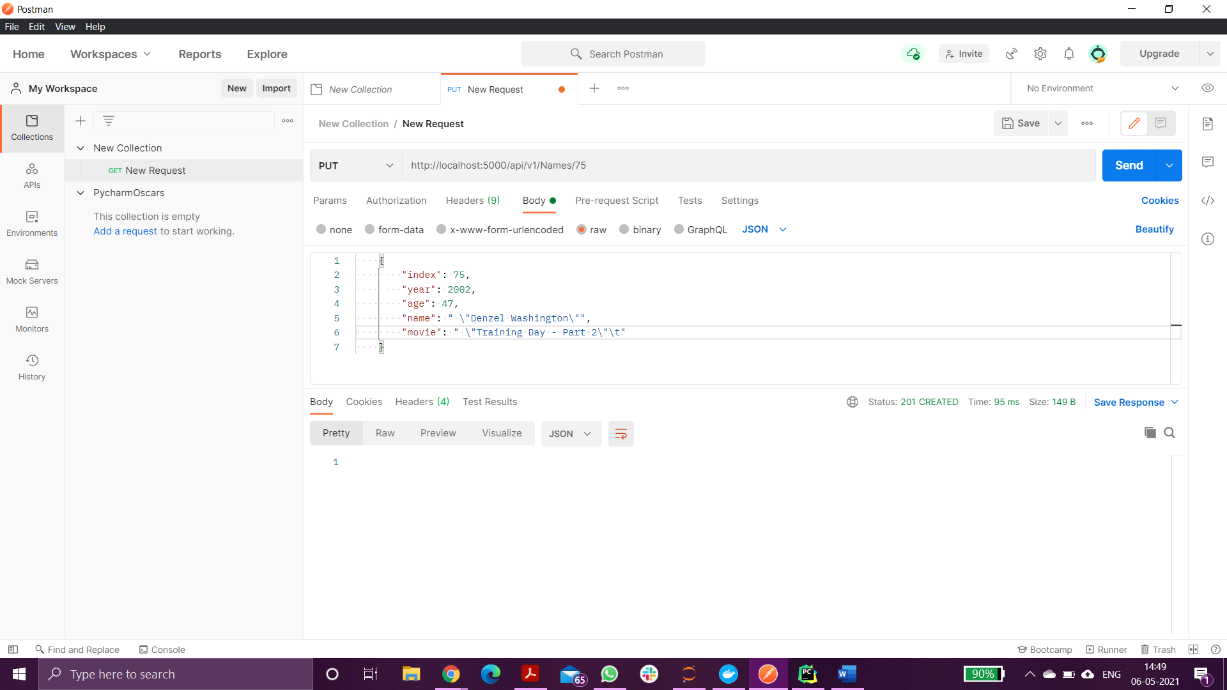

Result in this Screenshot:

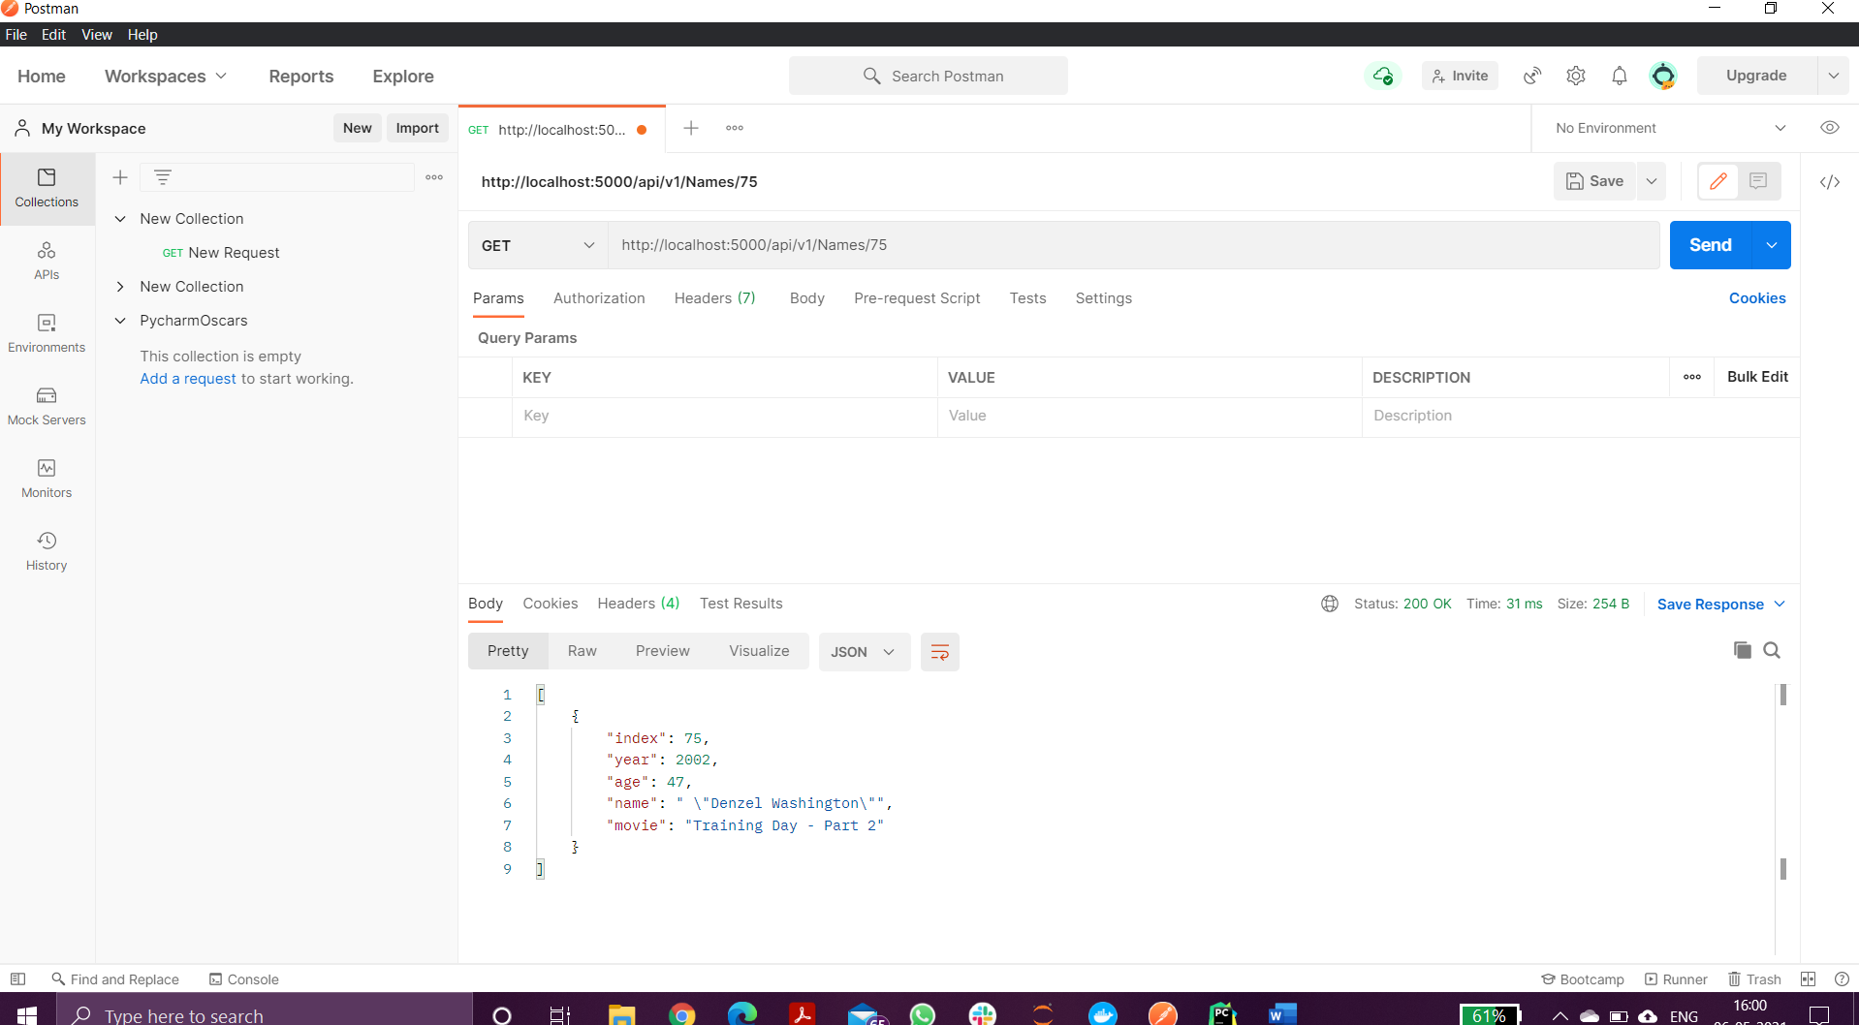

* 1. *e.* ***YOUR*** *project showing postman delete a record by showing the delete request and the results in the record listing*

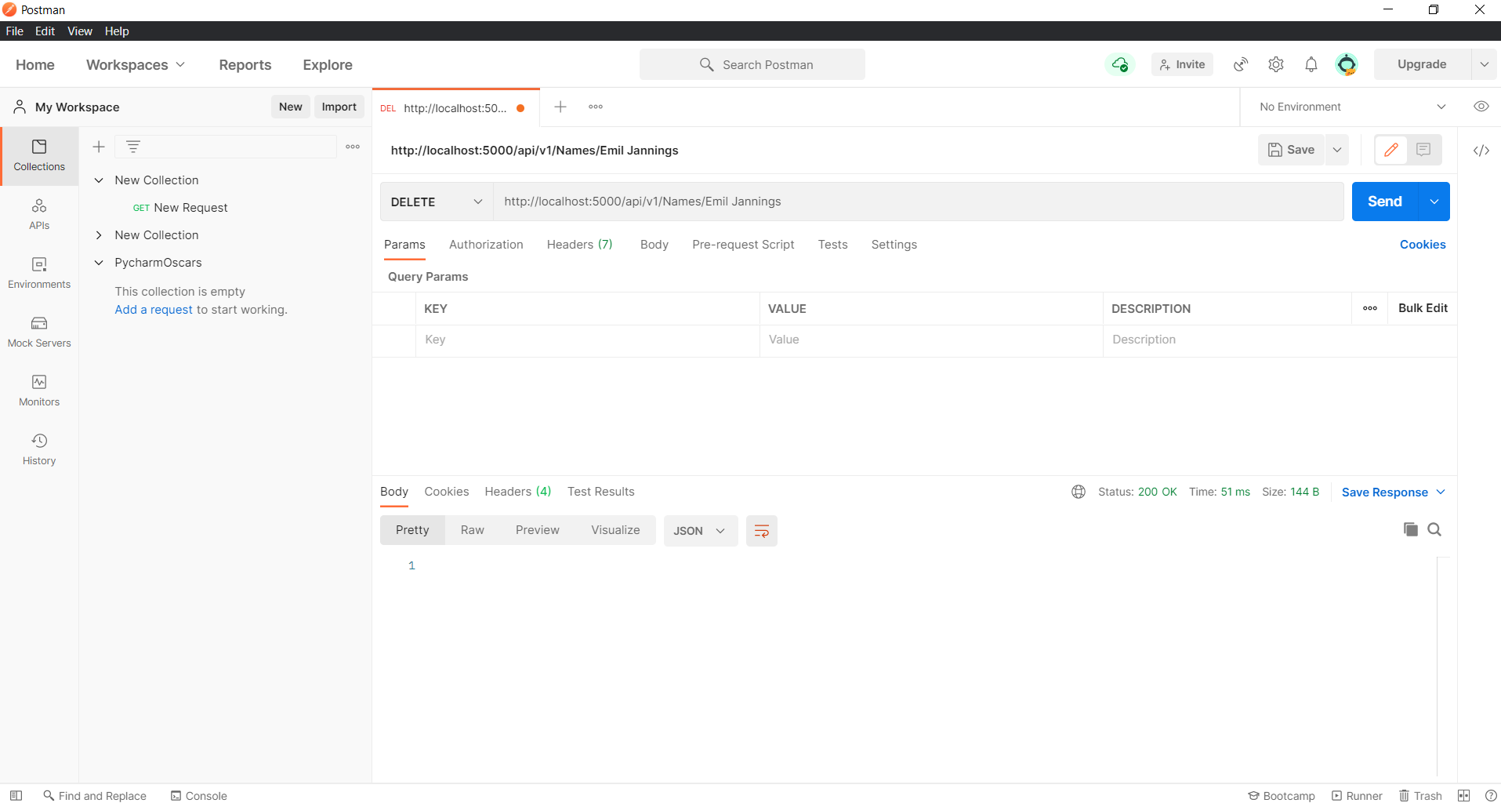

You can see, in the below screenshot, 1st record has been deleted.

